**Practical 2**

**Familiarization with Transmission media and Tools**

**What is transmission media?**

Transmission media is a pathway that carries the information from sender to receiver. We use different types of cables or waves to transmit data. Data is transmitted normally through electrical or electromagnetic signals.

An electrical signal is in the form of current. An electromagnetic signal is series of electromagnetic energy pulses at various frequencies. These signals can be transmitted through copper wires, optical fibers, atmosphere, water and vacuum Different Medias have different properties like bandwidth, delay, cost and ease of installation and maintenance. Transmission media is also called Communication channel.

**Types of Transmission media**

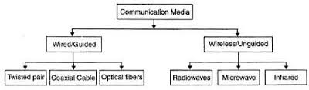

**1. Wired or Guided Media or Bound Transmission Media**

Wired or Guided Media or Bound Transmission Media: Bound transmission media are the cables that are tangible or have physical existence and are limited by the physical geography. Popular bound transmission media in use are twisted pair cable, co-axial cable and fiber optical cable. Each of them has its own characteristics like transmission speed, effect of noise, physical appearance, cost etc.

**2. Wireless or Unguided Media or Unbound Transmission Media**

Wireless or Unguided Media or Unbound Transmission Media: Unbound transmission media are the ways of transmitting data without using any cables. These media are not bounded by physical geography. This type of transmission is called Wireless communication. Nowadays wireless communication is becoming popular. Wireless LANs are being installed in office and college campuses. This transmission uses Microwave, Radio wave, Infra red are some of popular unbound transmission media. ance. Transmission media is also called Communication channel.

**Guided Transmission Media**

**Types of Twisted Pair**

The two types of twisted pairs are:

1. Unshielded twisted pair (UTP) ,2. Shielded twisted pair (STP)

1. Unshielded Twisted Pair (UTP): It consists of colour-coded copper wires, but does not include any foil or braiding as insulator to protect against interference. Wire pairs within each cable have varied amounts of twists per foot to produce cancellation. There are different categories of UTP. The following table shows the UTP categories, the no. of pairs in each, and the grade of cable each uses and how they are implemented.

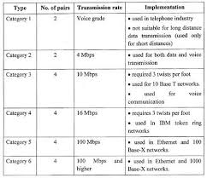

**Shielded Twisted Pair (STP)**

STP is made up of pairs of copper wires that are twisted together. The pairs are covered in a foil or braided mesh, as well as outer PVC jacket. This foil or mesh prevents the penetration of electromagnetic noise and eliminate cross talk. This shielding must be grounded to prevent the foil or braided mesh from becoming a magnet for electricity.

**Coaxial Cable**

Coaxial cable has two wires of copper. The core wire lies in center and is made of solid conductor. Core is enclosed in an insulating sheath. Over the sheath the second wire is wrapped around and that too in turn encased by insulator sheath. This all is covered by plastic cover.

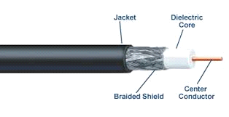

Because of its structure coax cables are capable of carrying high frequency signals than that of twisted pair cables. The wrapped structure provides it a good shield against noise and cross talk. Coaxial cables provide high bandwidth rates of up to 450 mbps.

There are three categories of Coax cables namely, RG-59 (Cable TV), RG-58 (Thin Ethernet) and RG-11 (Thick Ethernet. RG stands for Radio Government.

**Fiber-Optics Cable**

A cable with central glass tube covered with protective shield which transmit data using photons is fiber optics cable. These cables transmit data via concentrated bursts of laser beams which are carried through bundles of hair thin glass fibers.

They have advantages over electronic cables in transmission speed and volume. This technology has revolutionized telecommunication applications which used electronic cables. Fiber optics cables as free from electro-magnetic interference as well as wire tapping. fiber optics cable considered a broad band communication channel.

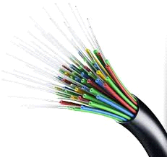

**Unguided Transmission Media:-**

Unguided transmission media extend beyond the limiting confines of cabling. They provide an excellent Communication Networks alternative for WANS. The lack of physical restrictions provides larger bandwidth as well as wide area capabilities. Unbound media typically operate at very high frequencies. The three types of unbound transmission media are:

1) Radiowave

2) Micro wave

3) Infrared

**Radiowaves Transmission** Although Radio waves are prevalent and well understood, we are just beginning to realize their enormous potential as a networking medium. Radio waves operates on a single or multiple frequency bands. Radiowaves are omni directional i.e. they travel in all the directions from the source. Because of this property, transmitter and receiver need not to be aligned. Radiowaves can penetrate buildings easily, so they are widely use for communication both indoors outdoors.

At high frequencies, radiowaves tends to travel in straight line and bounce off the obstacles. They are also absorbed by rain. Radiowaves me widely used for AM and FM radio, television, cordless telephone, cellular phones, paging and wireless LAN.

**Microwave Transmission** :Microwaves waves can operate on a single or multiple frequency bands have been used in data communications for a long time. They have a higher frequency than radio waves and therefore can handle larger amounts of data.

Microwave transmission is line of sight transmission. The transmit station must be in visible contact with the receive station. This sets a limit on the distance between stations depending on the local geography. Typically the line of sight due to the Earth's curvature is only 50 km to the horizon! Repeater stations must be placed so the data signal can hop, skip and jump across the country. microwave circuits considered a broad band communication channel. Microwaves operate at high operating frequencies of **3 to 10 GHz.** This allows them to carry large quantities of data due to their large bandwidth.

**InfraRed**.

Infrared offers a great unbound photonic solution. Like fiber-optic cabling, infrared communications use light,so they are not bound by the limitations of electricity.

**Crimping tool**

A crimping tool is a tool designed to crimp or connect a connector to the end of a cable. For example, network cables and phone cables are created using a crimping tool to connect the RJ-45 and RJ-11 connectors to the end of the cable. In the example below picture, this crimper is capable of crimping a RJ-11 (6-Pin) and RJ-45 (8-Pin) connectors and also includes a wire cutter near the handles that can be used to cut phone or CAT5 cable.

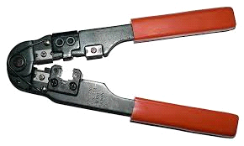

**RJ-45 Connecter**

The RJ-45 connector is a form of telephone connector. It sees its most frequent use as a local- area network connector, and is frequently referred to simply as an Ethernet connector.

